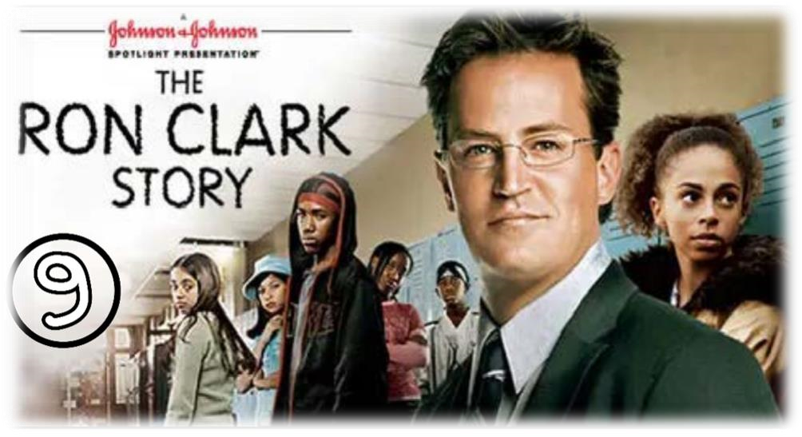

SCENE PPARATION

Scene summary:
At the beginning of the scene , we saw Mrs. Wallace in the principal's office. She was really angry and claimed the presence of Mr. Clark at her home the previous night . Mr. Clark succeeded, not only, to calm her down but to convince her to help Shameika in her homework . Later in the scene, Mr. Clark got sick and went to the hospital where the doctor suggested him to be confined to bedrest for two weeks. Despite his health's state, Mr. Clark didn't follow those instructions. Because of that , he couldn't do his course and finished by fainting in front of his students .

Scene Discussion & Analysis:
- Q01: Who is Mrs. Wallace? And what does she look like?
- Mrs. Wallace is Shamaika’s mother . She is a nice middle aged dark skinned woman . She is short and chubby . she has a long straight dark hair with dark eyes .

- Q02: Based on your understanding, why Mrs. Wallace didn’t like her daughter to be given grand ideas to dream big? (tricky question!!!)
- She finds hard to believe on her daughter’s abilities and she is afraid that if she dreams big the real world will crash her down .
- Q03: Could Mr. Clark convince her to keep her daughter in school eventually?
- Yes , he could .
- Q04: Mr. Clark fell sick ... what was his condition based on the doctor’s diagnosis?
  - Mr. Clark fell sick . He was diagnosed with pneumonia .
- Q05: What did the doctor recommend him to do? And did he follow the doctor’s instructions?
- The doctor recommended him to stay confined in bed for two weeks but he didn’t follow her instructions .

Acquired Vocabulary (OPTIONAL):

► Babysitting / babysitter:
    - Example in a sentence:
“ A working mother leaves her kids with a babysitter “
► To fire (someone): to kick someone out
    - Example in a sentence:
« The manager has fired all employees .
► A gifted kid
    - Example in a sentence:
“ Messi was a gifted kid in football .
Irregular Verbs:

Infinitive | Past simple | Past participle
To be | Was / were | Been
To come | Came | Come
To send | Sent | Sent
To deal | Dealt | Dealt
To keep | Kept | Kept

ADDITIONAL EXERCISE (OPTIONAL)

Task: Transcribe sentences from the scene.
- Transcribe Sentence 01
- Shamaika has more potential than any kid in my class , Why can’t you see that ?
- Transcribe Sentence 02
- I just know she’s a great student a born leader , creative , intelligent

- Transcribe Sentence 03

- Remember that I have eyes in the back of my head , so stop fighting .

